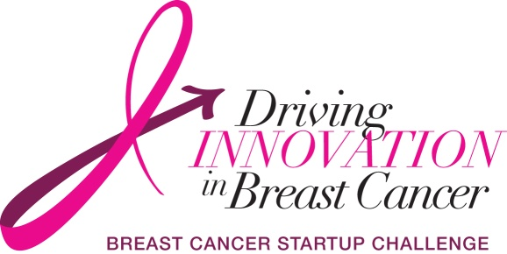
Breast Cancer Challenge Prize Allocation Form
At the end of the Business Plan Phase of the Breast Cancer Challenge (final pitches due 1/28/2014), the Challenge judges will put together their final evaluations and make the final decision for the winners on February 4th 2014. A maximum of 3 teams will move on to the Startup Phase; the first place winner of those teams will receive the Breast Cancer Challenge prize of $5000.
The $5000 will be distributed by the Center of Advancing Innovation to the winning team’s Team Leader. The prize will be in the form of one check paid to the order of .
It is the responsibility of the Team Leader to distribute the $5000 prize to his/her teammates. The Avon Foundation, the Center for Advancing Innovation, and the National Cancer Institute hold no responsibility in allocating winnings besides to the winning team’s Team Leader.
Please see below the form for the potential allocation of prize winnings from The Breast Cancer Challenge. Print all of the Team Members’ names below along with the percent allocated to each. All of the team’s members shall sign this form, confirming they have read the terms and accept the allocated amount to their person. If there are more than 10 members on your team, add more lines below and print.
Print Name |  | % Allocated |  | Signature
1.
2.
3.
4.
5.
6.
7.
8.
9.
10.

